|  |  |  |  |  |  |  |
| --- | --- | --- | --- | --- | --- | --- |
| VILNIAUS KOLEGIJA  UNIVERSITY OF APPLIED SCIENCES  FACULTY OF ELECTRONICS AND INFORMATICS  Image result for viko logo | | |  | | | VILNIUS COLLEGE  Image result for viko logoFACULTY OF ELECTRONICS AND INFORMATICS |
|  | | |  | | |  |
| **SMART DEVICE SENSORS PROGRAMMING** | | |  | | | **INTRODUCTION TO INFORMATICS** |
| LABORATORY WORK  LABORATORY WORK NR.: 4  6531BX028 PI18E | | |  | | | PRACTICAL ASSIGNMENT  SPOTIFY USER MANUAL  6531BX028 PI18E |
| STUDENT | DŽIUGAS PEČIULEVIČIUS | STUDENT | | DŽIUGAS PEČIULEVIČIUS |
| (SIGNATURE)  2/12/2021 | | |  | | | LECTURER |
| LECTURER | SIMONAS ČESNAUSKAS | (SIGNATURE)  10/17/2018 | | VIRGILIJUS KUKLIERIUS |
| (SIGNATURE)  2/12/2021 | | |  | | | 2018 |

2021

Questions:

1. Using theoretical calculations and using multisim software (suitable measurement component), calculate the total resistance of the scheme below.

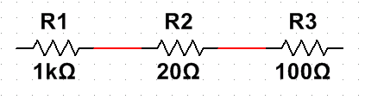

1. Using theoretical calculations and using multisim software (suitable measurement component), calculate the total resistance of the scheme below.

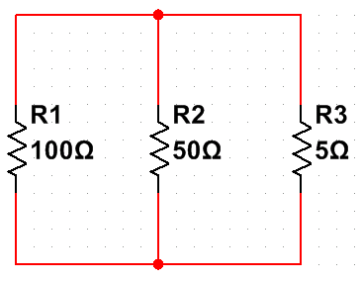

1. Assemble the diagram below in the multisim software. Measure the current the circuit consumes from the power supply. Base the measurement on theoretical calculations.

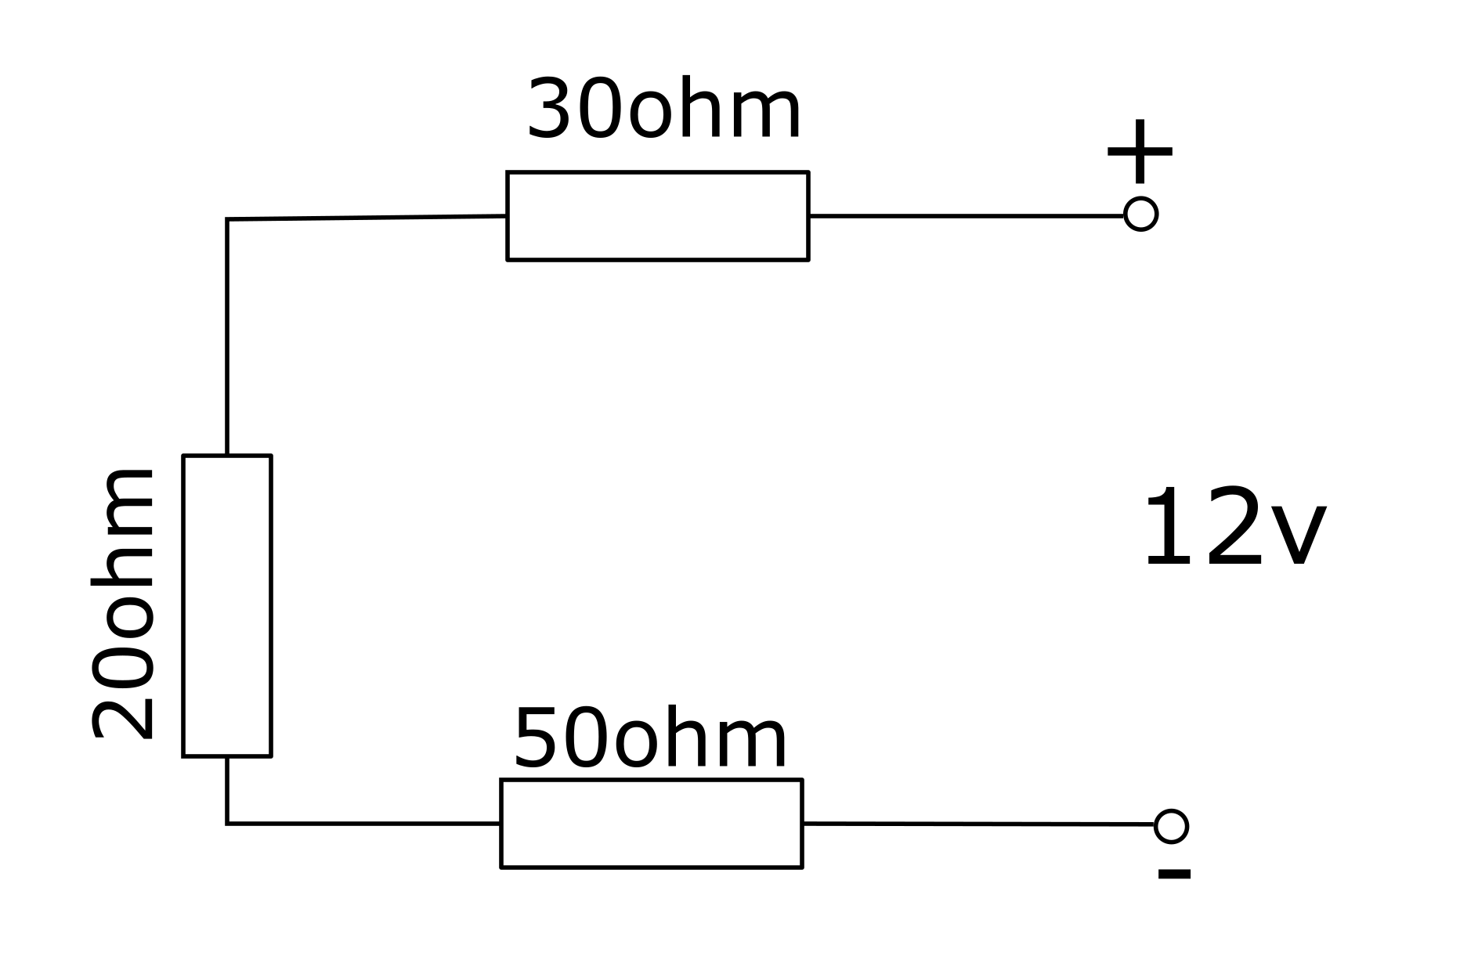

1. Assemble the diagram below in the multisim software. Measure its resistance.

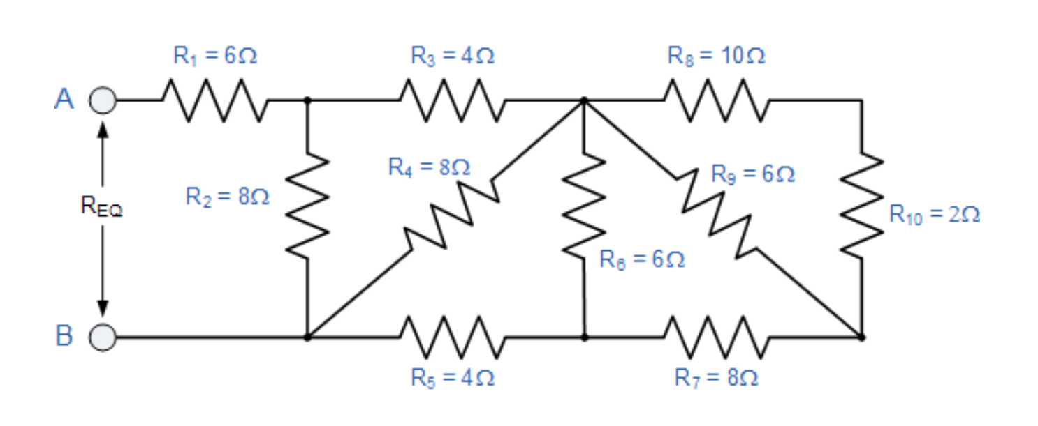

1. You have a blue LED, and a 12V power supply. Using theoretical calculations and multisim software, specify which resistor we will use to connect the LED and assemble the circuit in the multisim program. Then use measuring devices to show the voltage drop across the resistor and what current the circuit consumes.

Answers:

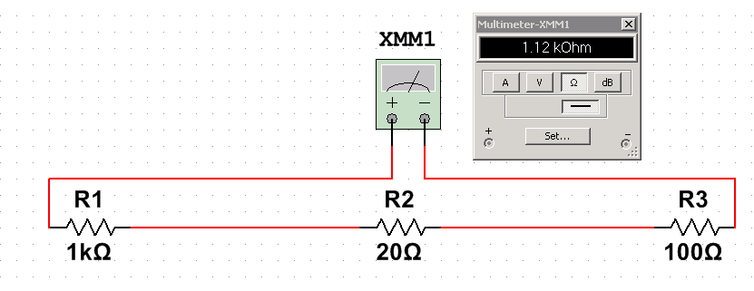

All we got to do is add up all the resistance. R = 1000 + 20 + 100



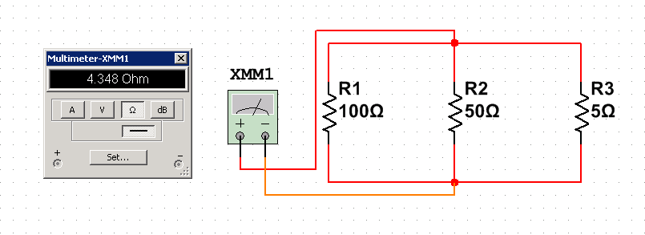

In this case resistance is calculated like this: R = 1 / (1/100 + 1/50 + 1/5)

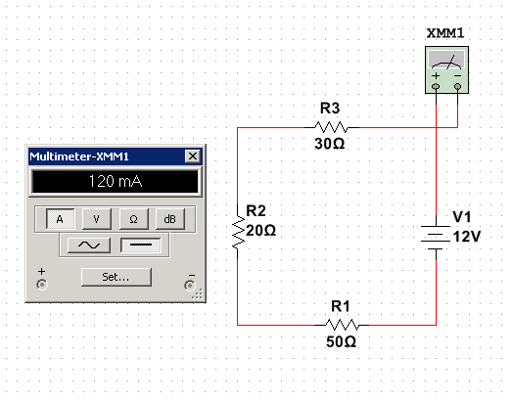

**I = V / R ; I = 12/100 = 0.12A = 120mA**

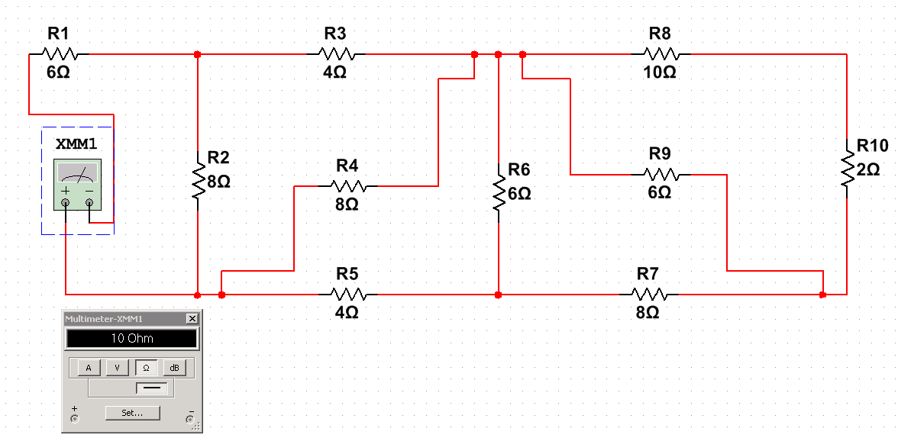

RA = R9 x (R8 + R10) / R8 + R9 + R10 = 4Ω.

RB = R6 x (RA + R7) / RA + R6 + R7 = 4Ω.

RC = R4 x (RB + R5) / R4 + RB + R5 = 4Ω.

RD = R2 x (RC + R3) / R2 + RC + R3 = 4Ω.

RD + R1 = **10Ω**

1. .

